//Vincent Wilmet HW4

//vincent.wilmet@student-cs.fr

//init

db.getCollectionNames**()**

//Q1

db.artistsnestedsongs.findOne**()**

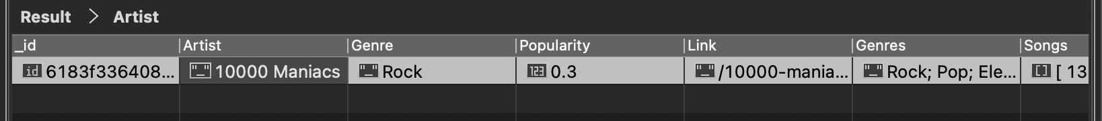

//Q2

db.artistsnestedsongs.find**({**"Link" **:** **{**$exists **:** true **}},** **{**"Artist"**:**true **,** "Genre"**:**true**})**

//Q3

db.artistsnestedsongs.find**({** "Artist"**:** **{** $regex**:** "Stones"**,** $options**:** "i" **}},** **{**"Artist"**:**true**})**

//Q4

db.artistsnestedsongs.find**({** "Artist"**:** **{** $regex**:** "Stones"**,** $options**:** "i" **}},** **{**"Artist"**:**true**})**.size**()**

2

//Q5

db.artistsnestedsongs.find**({** "Popularity"**:** **{**$gt**:** 4**}** **},** **{**"Artist"**:** true**})**

//Q6

db.artistsnestedsongs.find**({** "Popularity"**:** **{**$eq**:** 0**}** **},** **{**"Artist"**:** true**})**

//Q7

db.artistsnestedsongs.find**({**"Songs"**:** **{**$gt**:** **{**$size**:** 10**}}},** **{**"Artist"**:** true**})**

//Q8

db.artistsnestedsongs.find**({**"Songs"**:** **{**$size**:** 0**}},** **{**"Artist"**:** true**})**

//Q9

db.artistsnestedsongs.distinct**({**"Songs"**:** **{**$gt**:** **{**$size**:** 10**}}})**.find**({**"Artist"**:** true**})**

//Q10

db.artistsnestedsongs.find**({},{**"Genres"**:** true**,** "Artist"**:** true**})**.limit**(**40**)**

//Q11

//this list is specified by seperating each subgenre with a semicolon.

//if we want to query this attribute we can use $regex or $match

//Q12

db.artistsnestedsongs.find**({**"Genres"**:** **{** $regex**:** "Folk"**,** $options**:** "i" **}},** **{**"Artist"**:**true**})**.size**()**

322

//Q13

**db**.**artistsnestedsongs**.**aggregate([**

**{**

"$unwind" **:** "$Songs"

**},**

**{**

"$group"**:**

**{**

"_id"**:** **{**

"Genre"**:** "$Genre"**,**

"Language"**:** "$Songs.Idiom"

**},**

"Number_of_Songs"**:** **{**

"$sum"**:** NumberInt**(**1**)**

**}**

**}**

**},**

**{**

"$project" **:**

**{**

"Genre" **:** "$_id.Genre"**,**

"Language" **:** "$_id.Language"**,**

"Number_of_Songs" **:** true**,**

**}**

**},**

**]);**

